The Global Reference Architecture (GRA)

Charge Disposition Error Reporting Service (CDERS)
v 1.0.1

Service Description Document

Version 1.0.1

By
California Disposition Reporting Improvement Project

November 2013

This project was supported by Grant No. 2010-DG-BX-K164 awarded by the Bureau of Justice, Office of Justice Programs in collaboration with the U.S. Department of Justice’s Global Justice Information Sharing Initiative. The opinions, findings, and conclusions or recommendations expressed in this publication are those of the author(s) and do not necessarily reflect the views of the U.S. Department of Justice.

Table of Contents

1. Introduction to GRA Service Specifications 2
2. Service Overview 3
2.1 Purpose 3
2.2 Scope 3
2.3 Capabilities 3
2.4 Real-World Effects 3
2.5 Summary 3
2.6 Description 3
2.7 Security Classification 3
2.8 Service Specification Package Version 4
3. Business Scenarios 4
3.1 Business Scenario – Report Disposition 4
3.1.1 Primary Flow 4
3.1.2 Alternative Flows 5
4. Service Interoperability Requirements 5
4.1 Service Interaction Requirements 5
4.2 Service Assumptions 6
4.3 Service Dependencies 6
4.4 Execution Context 7
4.5 Policies and Contracts 8
4.6 Security 8
4.7 Privacy 8
4.8 Other Requirements 8
5. Additional Information 8
6. Service Model 8
6.1 Information Model 8
6.1.1 IEPD Reference 8
6.1.2 Data Inputs 8
6.1.3 Data Outputs 8
6.1.4 Data Provenance 9
6.2 Behavior Model 9
6.2.1 Action Model 9
6.2.2 Process Model 9

Introduction to GRA Service Specifications

In the context of the GRA and Service-Oriented Architecture [soa] in general, a service is the means by which one partner gains access to one or more capabilities offered by another partner. Capabilities generate real-world effects that can be as simple as sharing information or can involve performing a function as part of a complex process or changing the state of other related processes. Government organizations have numerous capabilities and a multitude of partner organizations, both inside and outside of their traditional communities. There are significant benefits for these organizations to share information and have access to each other's capabilities. Achieving interoperability among these organizations requires alignment of business and technical requirements and capabilities. In addition, it is critical to have a consistent way of specifying these requirements and capabilities and sharing them across organizational boundaries. The GRA was developed to facilitate interoperability and to assist in meeting other key requirements common in a complex government information sharing environment. In order to achieve interoperability, a consistent approach must be defined to identify, describe, and package services and their interactions in many different technical environments, across multiple government lines of business, at all levels of government, and with partner organizations.

The GRA defines a service interface as “the means for interacting with a service.” It includes specific protocols, commands, and information exchange by which actions are initiated on the service. A service interface is what a system designer or implementer (programmer) uses to design or build executable software that interacts with the service. That is, the service interface represents the “how” of the interaction. Since the service interface is the physical manifestation of the service, best practices call for service interfaces which can be described in an open-standard, machine-referenceable format (that is, a format which could be automatically processed by a computer).

A Service Specification is a formal document describing the capabilities made available through the service; the service model that defines the semantics of the service by representing its behavioral model, information model, and interactions; the policies that constrain the use of the service; and the service interfaces which provide a means to interacting with the service. A Service Specification is analogous to the software documentation of an Application Programming Interface [api]. It provides stakeholders with an understanding of the structure of the service and the rules applicable to its implementation. It gives service consumers the information necessary for consuming a particular service and service providers the information necessary for implementing the service in a consistent and interoperable way.

The main components of a Service Specification are the Service Description, one or more Service Interface Descriptions, and the schemas and the samples used to implement and test the service.

A Service Description contains information about all aspects of the service which are not directly tied to the physical implementation of the service; in other words, the service interface. A Service Interface Description is a description of the physical implementation; specifically, the service interface used in a specific implementation of the service. Since a service can leverage multiple Service Interfaces, the Service Specification might contain more than one Service Interface Description.

This document is a Service Description of the Charge Disposition Error Reporting Service (CDERS).

Service Overview

Purpose

The Charge Disposition Error Reporting Service (CDERS) supports the reporting of a charge disposition error where the issuing entity was unable to successfully process the charge disposition.

Scope

Capabilities

- Issuance of a disposition error to a reporting entity (the Information Service Backbone at the California Administrative Office of the Courts).

Real-World Effects

- The reporting entity receives a charge disposition error from the issuing entity and handles the subsequent distribution of the charge disposition error message.

Summary

The CDERS automates the charge disposition error issuance and reporting process by providing the reporting entity with an electronic version of a charge disposition error that occurred while attempting to update a criminal history record.

Description

The CDERS automates the issuance of a disposition error by providing a reporting entity with a disposition error contained in a previously reported charge disposition. The CDERS is described in terms of generic entities rather than the specific lines of business. The following list provides the entities associated with this service.

- Issuing Entity (Criminal History Repository)
- Reporting Entity (Intermediary)

Security Classification

- Disposition errors are used only for authorized criminal justice purposes.

Service Specification Package Version

This service specification is based on version 1.0.0 of the Service Specification Package.

Business Scenarios

Business Scenario – Report Disposition

The Issuing Entity sends a disposition error message to the Reporting Entity.

The following table summarizes the responsibilities of each entity associated with this service as depicted on the process flow diagram:

Role | Report Charge Disposition Error Responsibilities | Examples
Issuing Entity | - Publishes a charge disposition error when encountered during disposition processing. | - Criminal History Repository
Reporting Entity | - Receives a disposition error message from an issuing entity and handles routing of the charge disposition error | - Intermediary

Primary Flow

- The issuing entity sends a charge disposition error message to the reporting entity.

The following process flow diagram (Figure 1) depicts the charge disposition error reporting process flow shown in the ‘boxed’ section of the diagram.

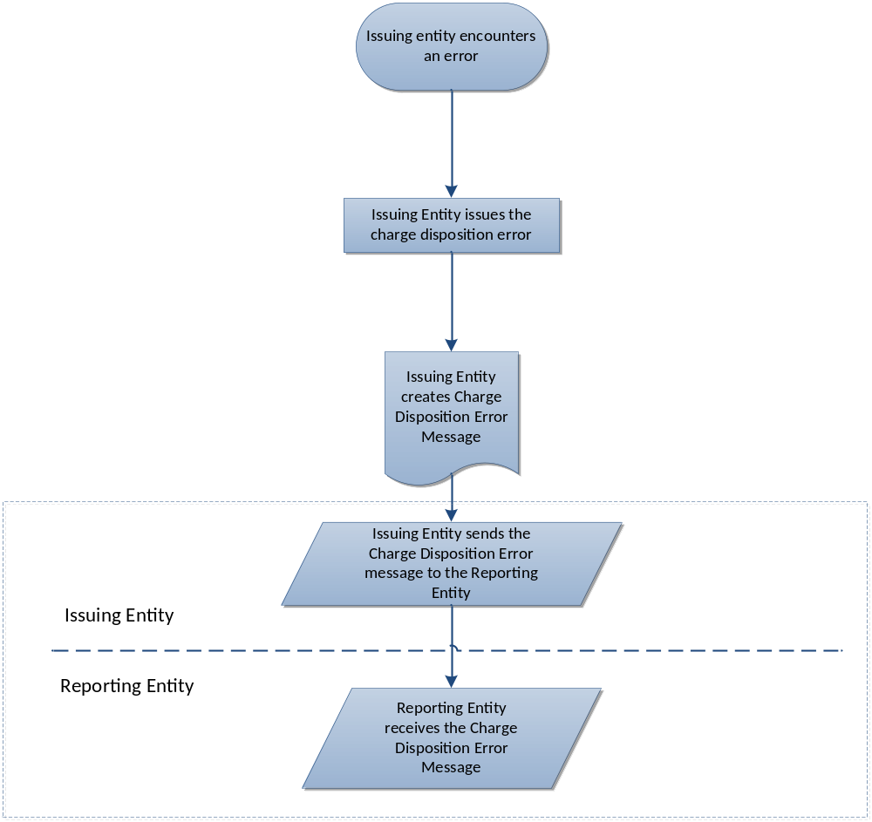

Note: Click here for a larger view of the diagram.

Figure 1 – CDERS Process Flow Diagram

Alternative Flows

N/A

Service Interoperability Requirements

Service Interaction Requirements

Requirements | Mandatory (Yes/No) | Justification/Notes
Service Consumer Authentication  Ensures that the service uniquely identifies and confirms consumer’s identity. | Yes
Service Consumer Authorization  The service requires the consumer assert their ability/permission to perform certain actions or access information via the service. | Yes
Identity and Attribute Assertion Transmission  Confirms the validity of information about a human or machine, including its identity. | No
Service Authentication  The service provides a consumer with information that demonstrates the service’s identity to the satisfaction of the consumer. | Yes
Message Non-Repudiation  Messages contain information that confirms the message was in fact sent by the authorized sender. | Yes
Message Integrity  Allows the message recipient to confirm the message content has not been altered after left control of the sender | Yes
Message Confidentiality  Prevents an unauthorized recipient from accessing the message, or part of the message | Yes
Message Addressing  Confirms the message origination, destination, directed recipient, and specific address or entity to route any reply/response messages. | Yes
Reliability  Permits senders/receivers to notify of successful or unsuccessful message transmissions and include any specified sequence related rules either to arrive as intended or fail as a group (e.g., batch transmissions). | No
Transaction Support  Allows for a sequence of messages (batch transmission) to be treated as a single transaction by the recipient. | No
Service Metadata Availability  Allows the service to provide or publish descriptive or categorical metadata to assist consumers interact with the service | No
Interface Description Requirements  Confirms or demonstrates how the service interface conforms to the GRA interaction profile. | Yes

Service Assumptions

- All messages exchanged will require a synchronous acknowledgement of receipt.
- The acknowledgement of receipt will only contain metadata about the message. The metadata will consist of a timestamp and identifiers that uniquely identify the message.
- Messages other than the synchronous acknowledgement are returned asynchronously. As such, the sending and receiving entity systems implement a service endpoint to receive these messages.

Service Dependencies

No dependencies have been identified at this time

Execution Context

The service design will follow the GRA Execution Context Requirements. The GRA Execution Context Requirements guarantees that there is appropriate and necessary support for interaction between all services, and that the adapters, connectors, and intermediaries have proper environments in which to reside. Network connections will need to exist between participating agencies and the location of the intermediary host. Each endpoint location will need to provide a hardware environment for the containers. Figure 2 depicts a conceptual diagram of the Intermediary for the DRS.

Container – The environment where a service consumer would host its connector(s) or where a service provider would hosts its adapter(s).

Intermediary Host – The intermediary host can host a number of intermediary services to route messages, perform transformations, enact filters, etc.

Connector - The connector formulates a message from the service consumer in accordance with the service specification and sends the message to a service interface.

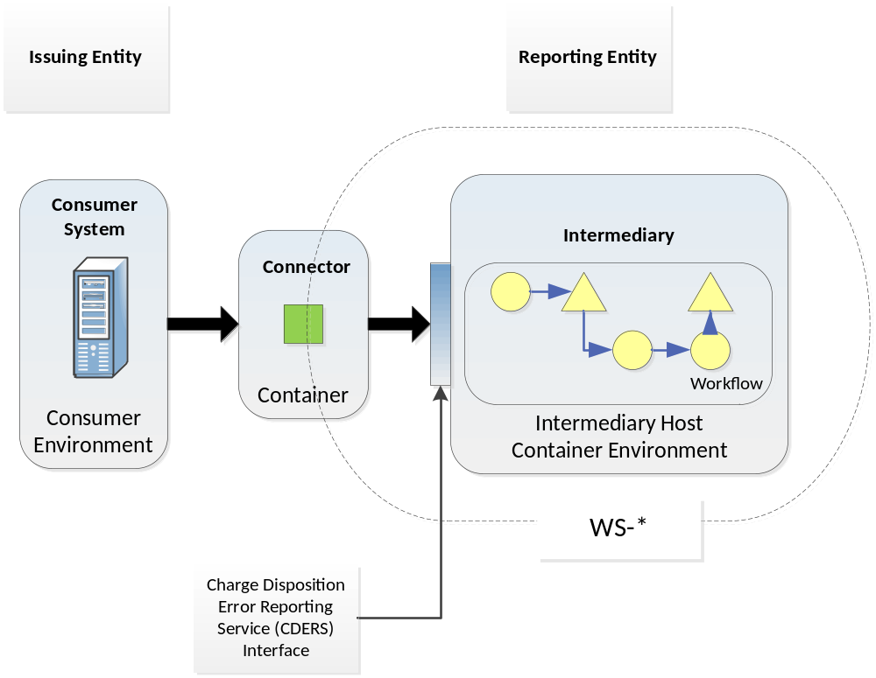

Figure 2 – CDERS Execution Context Conceptual Diagram

Policies and Contracts

(Add links to pertinent CA-DRIP MOUs, NDAs and SLAs here)

Security

- The service must adhere to the rules of the CJIS Security Policies regarding the Advanced Encryption Standard (AES) level of encryption.
- The use of Virtual Private Networks (VPNs) or Secure Sockets Layer (SSL) for transport-level security in addition to these requirements is optional.
- Security Requirements:
  - Message Non-Repudiation?
  - Message Integrity?
  - Message Confidentiality?

Privacy

Other Requirements

None identified at this time

Additional Information

None identified at this time

Service Model

Information Model

IEPD Reference

The Charge Disposition Error Reporting IEPD available at :

Data Inputs

- Charge Disposition Error Message

Data Outputs

All actions of the service return a synchronous response.

Data Provenance

The data exchanged by this service would originate at the partnering agencies. The provenance of the data will be restricted to those agencies.

Behavior Model

Action Model

Action Name | Report Charge Disposition Error
Action Purpose
The Reporting Entity implements this action to receive a charge disposition error message from the Issuing Entity
Action Inputs | Action Outputs
Charge Disposition Error Message | Response
Action Provenance
The provenance of this action is the same as the provenance of the service.

Process Model

The DRS process model is contained in the artifacts section of this specification. This process model illustrates the behavior of the service.

Appendix A - References

Global Reference Architecture Web Site | http://www.it.ojp.gov/globaljra

Appendix B—Glossary

MOU | Memorandums of Understanding
NDA | Non-disclosure Agreement
SBU | Sensitive but Unclassified

Appendix C—Document History

Date | Version | Editor | Change
1/22/2014 | 1.0.1 | Gary Gurbhej | Section 6.2.1: Action output t response

